|  |
| --- |
| GAMINDUSERI |
| AFTER MIDNIGHT |
| **A 2D Horror Platform Game** |
| Version #01  All work Copyright © 2016 by GAMENDUSERI Games.  All rights reserved. |
| **Andre Luiz da Motta Passos**  **Amit Kunal**  **Ronnel Ian Villarino**  **Ranjana Kalra** |
|  |

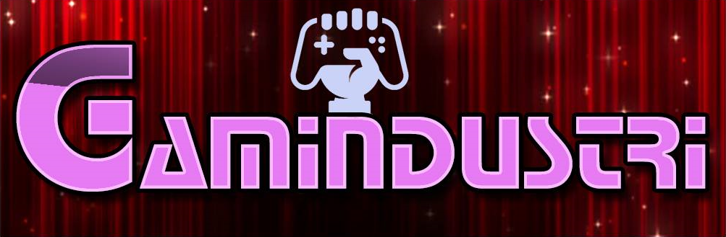

|  |
| --- |
| Dec 05th 2016 |

**Table of Contents**

1. Game Overview 4

3. Camera 4

4. Controls 4

5. Saving and Loading 4

6. Interface Sketch 4

7. Menu and Screen Descriptions 5

8. Levels 6

9. Characters 6

10. Enemies 7

11. Abilities 7

12. Sound Index 7

13. Future Features 7

**Version History**

Version 01 - This is the first version of After Midnight, we include one level with four different enemies, a main menu, and a game over screen. A basic animate attack is the player main weapon. To beat the level the player must kill all enemies in the scene.

# Game Overview

*A living nightmare awake in an abandoned castle, now Natalia must purge this evil before it gets out of control, carrying an ancient power even the nightmare creatures are in danger now.*

1. **Game Play Mechanics**

*This is a 2D platform game, the player must explore an ancient castle and kill and the enemies in his way.*

# Camera

*This game use a Third Person camera*

# Controls

*Use the left and right arrows keys to move and up arrow key to jump, press SPACE to perform an attack*

# Saving and Loading

*There are several checkpoints during the game, if the play died he will be teleport to the next checkpoint, if the player get stuck he can teleport himself to next checkpoint by pressing ESC and choice the option Go To Checkpoint*

# Interface Sketch

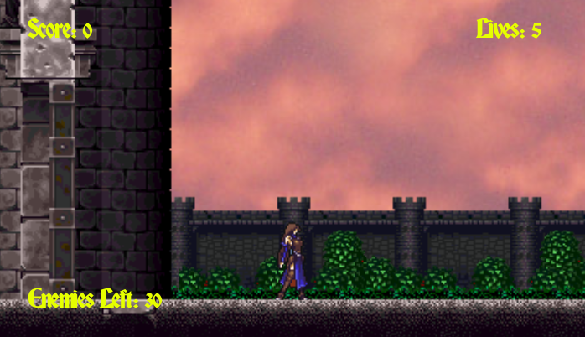

*The interface use 3 labels, one to mark scores, another to mark the lives and the last one to mark the enemies left, when the player kill all enemies he will able to go the next level.*

# Menu and Screen Descriptions

*Main Menu*

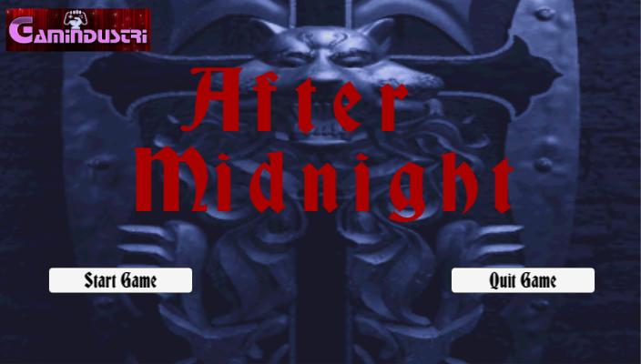

*Pause Menu*

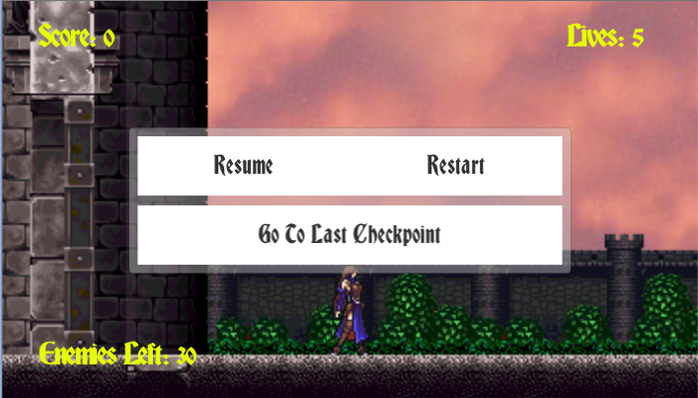

*Game Over Screen*

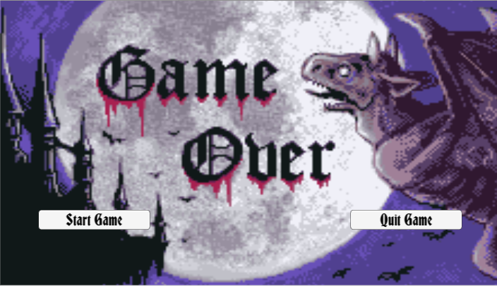

# Levels

*The game consists in 3 level, in different areas, to go to next level the player must kill all the enemies in the current level.*

# Characters

*Natalia – The last one of the Old Order, she is the blade who will vanquish all evil, now she must face the nightmares in this ancient castle.*

# Enemies

*The creature – This creep creature is made by many dead parts, do not underestimate him.*

*Frozen Spirit – A cold soul who is trapped in this world, put an end in her torment.*

*Ectoplasm – An abomination made by many lost spirit, kill him faster.*

*Skeleton – The dead don’t want to rest, put then to rest in peace forever.*

# Abilities

Fire Bite – This ancient magic can destroy all the evil, fire at will.

# Sound Index

*The background music is from Castlevania titles, they can be download in the internet and use for non-commercial application. Sound affect was created in the web site: http://www.bfxr.net/*

# Future Features

*For the next version, we will include more levels, fix some bugs, and add a collect system.*